**Steps for configure Openvpn**

Requirement :

* Centos VPN Server 1
* Centos Client 1
* Windows Client 1

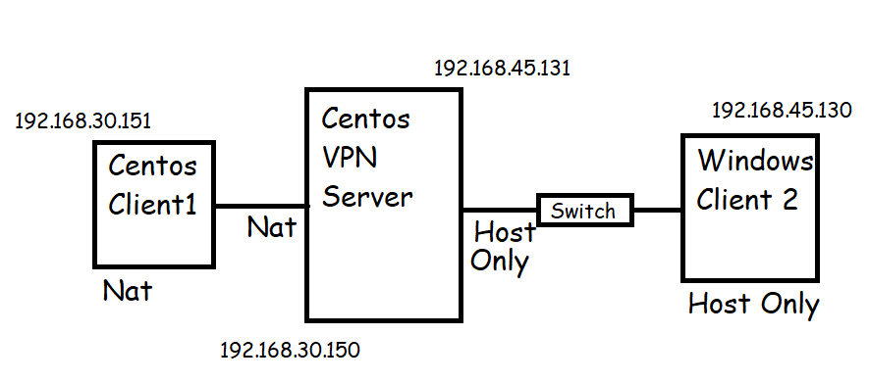

ON VPN Server:

# hostnamectl set-hostname vpnserver

# exec bash

# sestatus

# setenforce 0

# sed -i 's/SELINUX=enforcing/SELINUX=disabled/g' /etc/selinux/config

# getenforce

# vim /etc/sysctl.conf

net.ipv4.ip_forward=1

Add above text in the last line of sysctl.conf file.

# cat /proc/sys/net/ipv4/ip_forward

— to view the status code 0 or 1 if there is 0 then run the following command.

# echo 1 > /proc/sys/net/ipv4/ip_forward

# yum install epel-release -y

# yum install openvpn -y

# wget <https://github.com/OpenVPN/easy-rsa/releases/download/v3.0.6/EasyRSA-unix-v3.0.6.tgz>

# ls

# tar -xzvf EasyRSA-unix-v3.0.6.tgz

# ls

# mv EasyRSA-v3.0.6/ easy-rsa/

# cd easy-rsa/

# vim vars

set_var EASYRSA "$PWD"

set_var EASYRSA_PKI "$EASYRSA/pki"

set_var EASYRSA_DN "cn_only"

set_var EASYRSA_REQ_COUNTRY "INDIA"

set_var EASYRSA_REQ_PROVINCE "Maharashtra"

set_var EASYRSA_REQ_CITY "Pune"

set_var EASYRSA_REQ_ORG "Shiv IT Solution"

set_var EASYRSA_REQ_EMAIL "admin@demo.lab"

set_var EASYRSA_REQ_OU "Shiv"

set_var EASYRSA_KEY_SIZE 2048

set_var EASYRSA_ALGO rsa

set_var EASYRSA_CA_EXPIRE 7500

set_var EASYRSA_CERT_EXPIRE 365

set_var EASYRSA_NS_SUPPORT "no"

set_var EASYRSA_NS_COMMENT "Shiv IT Solution"

set_var EASYRSA_EXT_DIR "$EASYRSA/x509-types"

set_var EASYRSA_SSL_CONF "$EASYRSA/openssl-easyrsa.cnf"

set_var EASYRSA_DIGEST "sha256"

:wq save & exit